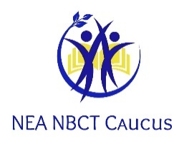

NEA-NBCT CAUCUS NEWSLETTER
October 2020 NEA-NBCT Caucus Chair: Mary Kay Scheid Editor: Annice M. Benamy
Web site: https://www.neanbct.org/
Visit us on Facebook, Twitter, and Instagram

A Virtual RA Experience
Because Nothing in 2020 is Normal
By: Logan Okita (Hawaii)
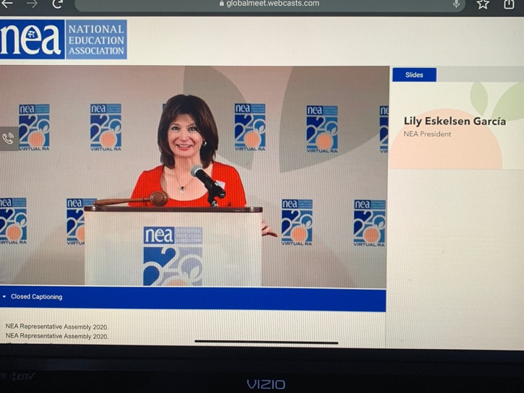
True to form for 2020, even the NEA Representative Assembly was virtual, abbreviated, and viewed from the location of your choice. My first RA experience was in Atlanta in 2013, so I was excited it return in July 2020. Instead of traveling 4490 miles from Honolulu to Atlanta, I participated this year from the comfort of my living room and connected with my colleagues and friends via text messages, zoom caucus meetings, Facebook posts, and Instagram stories.
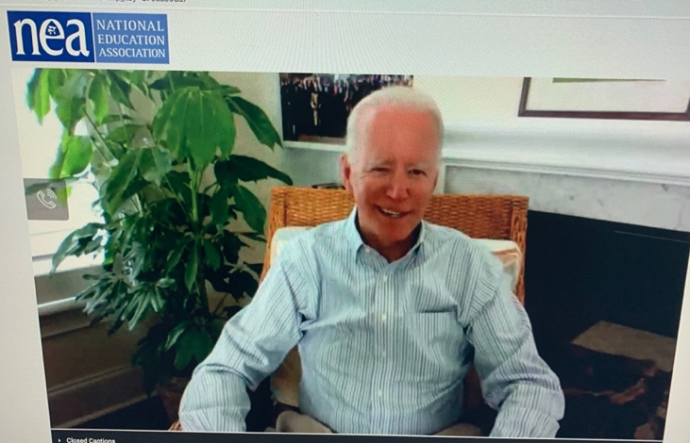
On the first day, delegates heard inspirational messages from Stacey Abrams and NEA President Lily Eskelsen Garcia and asked questions about the 2020-2022 Strategic Plan and Budget. Then Vice President Joe Biden, NEA Executive Director Kim Anderson, and awardees addressed the delegates on the second day. After hearing speeches from all of the candidates for this year’s NEA Elections, President Lily Eskelsen Garcia gave her last final address as NEA President.
While I missed connecting with friends I have made from other states through NEA activities, I enjoyed activities that allowed us to connect from home. The NBCT Caucus held a daily trivia activity and it was fun to play virtually and connect with new and old friends. One of the perks is that all of the speeches are available on NEA’s YouTube so that you can watch them again for inspiration throughout the year.
Stay healthy and I hope to see you at a NBCT Caucus meeting in Denver in 2021!

From Our Caucus Chair, MaryKay Scheid
Connect with the Caucus on Twitter @NEANBCTCaucus
Thank you for your membership in this caucus, a group that aspires to encourage accomplished teachers to participate in education on a larger stage. Aspiring and credentialed National Board Certified Teachers know effective teaching. They strive to collaborate and inspire their students; they shape the future through the work they do inside their classrooms. But the voices of these powerful educators’ need be heard by a larger audience than the students they serve. Our district administration, our local legislators, and our national leaders routinely establish policies that affect us behind our closed classroom doors. We need to make sure that these leaders are crafting policies with an informed mind. In this newsletter, you will learn of multiple opportunities to network with other outstanding educators, to develop the teaching craft, and to share your wisdom so that the classrooms of the future will continue to feature accomplished teachers and accomplishing learners. Enjoy!
NEA-NBCT CAUCUS NEWS…

On our October 4, 2020 NEA-NBCT CAUCUS ZOOM CALL, the Board voted to approve the NEA-NBCT CAUCUS MISSION STATEMENT:

Our goal is to advocate as the collective voice of the National Education Association members who are NEA NBCTs, NBCT candidates, and those NEA members who support the National Board process.

Calendar of 2020-2021 Caucus Meetings via Zoom:
- December 6, 2020
- February 7, 2021
- April 11, 2021
- June 6, 2021

WASHINGTON - August 06, 2020 - Below are remarks as prepared for delivery by NEA President-elect Becky Pringle after the National Education Association’s election results were announced. The NEA’s Representative Assembly, which was held virtually due to the COVID-19 pandemic, conducted the election via mail-in ballot for the health and safety of RA delegates and NEA staff.

“‘Eventually you get pushed to the point where it becomes uncomfortable to stay silent; to keep swallowing acts of oppression or injury. Then you’re compelled — to act...to stand up when other people tell you to sit down.’
“Just Mercy author, Bryan Stevenson, explains what happens when folks have had enough; when they realize that people don’t move when you show them the light. They move when they feel the heat.

“Good evening, RA delegates. I am humbled. I am honored. And I am ready. So, too, are you. We are ready to turn up that heat and be the leaders we must be in this moment.
“Please indulge my need to take a few minutes to express my deep gratitude. To my home state, Pennsylvania; PSEA [Pennsylvania State Education Association], thank you for your encouragement and support and love. To my NEA family — Thank you my executive committee colleagues, my new VEEP, Princess, and my President and sister Lily for their fierce and courageous leadership.
“And thank you to my parents who challenged and nurtured me; my extended family who have lifted me up; my children and their loving spouses who take care of me and fill me with such pride; my grandchildren who remind me why. And my husband who still watches over me; still pushes and pulls me; catches and loves me.
“And to you, my fellow co-conspirators in this fight for racial and social and education justice.
“Thank you for inspiring me with your determination and dedication. Thank you for always making this Black girl from North Philly, who just wanted to teach the children, be so incredibly proud to lead a union that stands for the rights, authority and excellence of educational professionals; a union that fights for the right of every student to have what they need to live into their brilliance; a union that embraces the magnitude of its responsibility that’s capture in the preamble of our mission:
“We, the members of the National Education Association of the United States of America, are the voice of education professionals. Our work is fundamental to this nation, and we accept the profound trust that has been placed in us.
“That profound trust has been truly tested over these last five months. I’ve seen you working so hard to continue our students’ learning despite the digital divide we already knew existed. Trying to stand in the gaps that are widening because of the inequities that have been built into interconnected social systems adversely compounding to impact the learning of far too many of our students.
“
“And here we are. Being bullied from the highest office in the land to reopen school buildings and campuses when we now have evidence that they’re unsafe. In frustration and anguish, the superintendent in Hayden Winkelman Unified School District in Arizona, told the truth: ‘I’d love to be open. [But] there’s no way it can be safe. If you think anything else…it’s a fantasy. Kids will get sick, or worse. Family members will die. Teachers will die, [one of mine already has]. I keep waiting for someone higher up to take this decision out of my hands and come to their senses. I’m waiting for real leadership, but maybe it’s not going to happen. It’s me.’
“It’s us, NEA. We must be those leaders. We’re done waiting for Donald Trump to come to his senses and stop this reckless rush to reopen our school buildings. We’re done waiting for Betsy DeVos to have clue, or care about our students. We done waiting for Mitch McConnell to do his job. And we’re done being forced to make the false choice between living and learning; blamed for the failure of this administration to bridge the gaps in equity and fairness. We’re done.
“I checked in on my Board colleague and friend Hilda, who teaches kindergarten in Indiana. They went back to their school buildings last week. I asked her if she felt safe; if her district had put in place the recommended safety guidelines. This is what she told me:
“‘I do not think we should be in school. We already have 40 students in one high school that had to be isolated. I have 24 students in my classroom. How can I social distance six feet? We were promised face shields, but we do not have face shields yet. Our governor is listening to Trump and Pence, so we’re not getting the help we need. My doctor friends tell me not to go teach. They say it is not safe.’
“I told her what she and her colleagues and students were being forced to go through was unacceptable, and we’re working to change what’s happening. I also told her I was holding her in my heart and keeping her in my prayers. But we can’t stop there.
“We’re wasting precious time talking about whether our schools are safe. We already know…
“They’re not safe if they’re in a community where the transmission rates are not low AND declining for the least the past two weeks
“They’re not safe if you don’t have the space to physically distance
“They’re not safe if you can’t provide masks and other protective equipment. If your school isn’t able to sanitize regularly, do daily health screenings and testing, or implement plans for when a student or educator tests positive for COVID-19…They’re not safe!
“We already know that.
“So, let’s stop wasting time! Our students need us to focus our energy on co-creating and sharing new teaching and learning strategies, harnessing the assets of our communities; they need us to come together to get the resources, do the planning and assess our learnings and adapt our practices. They need us to ensure every child has access to the educators and tools they need to learn; every child has the support of

professionals to address their mental and physical health. NEA, we must spend our time ensuring our students have what the need, when they need it.
“Those of you who have done the work to build community schools, to harness that power of shared responsibility, to access the assets of your community to surround your students and families with the support they need we need you to lead the way to our future.
“Those of you who have developed the processes and structures to sustain those labor-management collaboration partnerships look to those strategies to find common ground, we need you to organize for what’s right.
“For those of you who know the power of collective action, who launched the #RedForEd movement across this country, we need you to use your collective power to demand this country live up to its promise…
“And for those of you who know that every decision that’s made for our students and our schools is a political one, we need you to get everyone who knows you, likes you, loves you, or intends to keep living with to vote for Joe Biden and so we can end this national nightmare, and build back better!
“I know throughout this crisis you have suffered personally and professionally. You are grieving the loss family and friends. You are feeling the weight of not being with your students — not just guiding their academic pursuits but attending to their social-emotional needs so they can learn; so, they can thrive.
The suffering is real. The uncertainty, a constant.
“But this I know. NEA…We are ready.
“We are ready to demand the rights, respect, and authority we deserve as professionals. We are ready to lead our professions toward excellence through pandemic, and into the future.
“We are ready fight for racial and social justice for our students, and our communities and this country.
“NEA, we are ready to stand in our power, and lead in this moment.
“I’ve spent these last five months zooming with thousands of you, so I know you’re nervous about keeping everyone safe, and anxious about how to center your advocacy in equity. But know this. NEA will support your demands that you get what you need to safely do the jobs you love. And we need you to keep standing up for what’s right. And I commit to you the resources to use your teacher voice and fight. I commit to you the support to expand your ESP influence and ingenuity. Be it grassroots action or collective bargaining or legal challenges or political action,
“That is why one of my first orders of business as president-elect is to work with Lily and Princess to direct financial resources to support any affiliate who looks at their re-opening plan and doesn't feel safe asking our members to go back their school
“And we won’t stop there. We commit to you the resources to teach and nurture our children. And we’re not doing it alone. We’ve forging partnerships with the civil rights community and leaders like President Johnson of the NAACP and President Morial of the National Urban League and healthcare professional organizations like the American Academy of Pediatrics. And we will work together to get needed resources for families and create solutions for the growing inequities. Today, NEA

launched a partnership with our local PBS [Public Broadcasting Station] station (WETA) to provide parents with resources and support in special education, reading, and English Language Learners.
“Tomorrow we will launch nea.org/safeandjust. It will be a clearinghouse of resources you can access to connect with each other to improve your practice in a digital learning environment. It will keep you informed with data from experts. And it will provide you ideas and resources to take action. Because while some of your districts are committed to working with you to ensure the health and safety of all and the quality education of students, others are following the Trump playbook callously disregarding the expert guidance of healthcare professionals and educators. So, we’ve created a school board resolution to unite your communities around a commitment to protect and support their students and educators.
“You’ll also find guidance on how to form those critical community partnerships and develop collaborative practices to build our movement.
“Remember…One in every 100 Americans is an NEA member.
“NEA, we have the power and reach. We can do this.
“As I read John Lewis’ love letter to us published by the New York Times after he passed, I was struck by his compassion, and his clarity; his resilience and resolve. This civil rights icon who put his Black body on the line day after day because he believed it was his responsibility to take a stand against injustice. This man, who had been beaten to within an inch of his life told us that we ‘filled [him] with hope about the next chapter of the great American story when [we] used [our] power to make a difference in our society.’
“Through his powerful and compelling words he urged us ‘to answer the highest calling of [our] hearts; [to] stand up for what [we] truly believe.’
“When Congressman Lewis was asked why he and his fellow civil rights activists stood up, he said: ‘We had to do it. The spirit of history tracked us down and said this is your time. If you don’t get into good trouble, who will?’
“NEA…we will! My fellow NEA leaders, it’s us. It’s time. And we are ready. I need you to join me in reclaiming public education as a common good, as the foundation of this democracy, and transform it into a racial and socially just and equitable system that prepares every student, every one, to succeed in this diverse and interdependent world.
“NEA, this is our time!
“We will get into good trouble fighting the inequitable systems that allows some of our students to have every opportunity, while others are told we can’t afford it for them.
“We must get into good trouble to stop the march toward income inequality and unfettered power that allows that system to continue to stand.
“We will get into good trouble to bring an end to the sexist, homophobic, and racist structures and practices that have allowed those in power to belittle and diminish and destroy.

“NEA we will get into good trouble every day, in every state, in every community all across this nation to keep our students and educators safe and center our schools in equity and excellence.
“Because we cannot rest until all our students know that we will demand that this country live up to that small, but powerful first word of our constitution: ‘WE.’ It’s WE the people. That means all of us — women and men; gay, straight, transgender, non-binary; Black, white, brown; indigenous; differently abled. It means WE. All of us have that moral right to pursue happiness; to be fully human.
“And we know that moral arc of the universe doesn’t bend on its own. We have to bend it toward justice.
So, we will lift up our voices and we will not falter. We will lift up each other, and we will not give in. We will lift up our students, and we will not give up.
“Because our babies are depending on us to be worthy of them.
“NEA…we are ready! Onward.”
More resources are available at www.nea.org/ra
Follow on twitter at @NEAmedia and @BeckyPringle
Keep up with the conversation on social media at #NEARA2020
*********************************************************************The following candidates were declared elected to office
based on voting results August 5, 2020.
President (3-year term)
 |  | Votes | Percentage
Elected | Becky Pringle | 5056 | 93.37%
Vice President (3-year term)
 |  | Votes | Percentage
Elected | Princess Moss | 4718 | 88.37%
Secretary Treasurer (3-year term)
 |  | Votes | Percentage
Elected | Noel Candelaria | 3154 | 60.10%
NEA Executive Committee (3-year term)
 |  | Votes | Percentage
Elected | Hanna Vaandering | 3300 | 70.36%
Elected | Mark Jewell | 2026 | 56.97%
ESP At-Large Representatives (3-year term)
 |  | Votes | Percentage
Elected | Ashanti Rankin | 3558 | 92.26%
Elected | Saul Ramos | 3415 | 88.56%
Elected | Margaret Powell | 2917 | 75.64%
Elected | Lisa Jennings | 2200 | 57.05%
Elected | Stephanie Ervin | 2180 | 56.53%
Elected | Gerry French | 2099 | 54.43%
Elected | Gwendolyn Edwards | 2295 | 81.84%
Elected | Pamella Johnson | 2099 | 74.85%
Elected | Carmen Hill | 2066 | 73.67%
Declared Elected | Kathleen Meltsakos
Shall the NEA adopt the 2020-22 NEA Strategic Plan and Budget as presented?
 |  | Votes | Percentage
Passed | Yes | 4868 | 89.90%
 | No | 547 | 10.10%
Shall NEA endorse Joe Biden for President of the United States in the 2020 general election as recommended by the NEA Fund Council and Board of Directors?
 |  | Votes | Percentage
Passed | Yes | 4901 | 89.63%
 | No | 567 | 10.37%

From National Board of Professional Teaching nbpts.org:

The National Board’s Maintenance of Certification (MOC) process is designed based on best assessment practices and by teachers to ensure that National Board Certified Teachers continue to grow professionally while maintaining a strong impact on student learning.
Starting in September 2020, MOC is the pathway for NBCTs to keep their certification active. Successfully meeting MOC requirements will extend an NBCT’s certificate by five years from their current certificate’s expiration date.

MOC Facts:
Cost: MOC costs $495 plus a $75 registration fee. This cost is consistent with the National Board’s commitment to making all aspects of the National Board certification process as flexible, affordable and accessible as possible for our country’s diverse educators.
Timing: Based on pilot participant guidance, MOC took an average of 53 hours to complete.
Success rate: 9 out of 10 NBCTs successfully complete MOC.
Frequency: NBCTs must complete MOC every five years to keep their certification active.
For more information: www.nbpts.org.

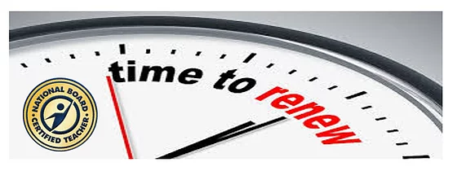

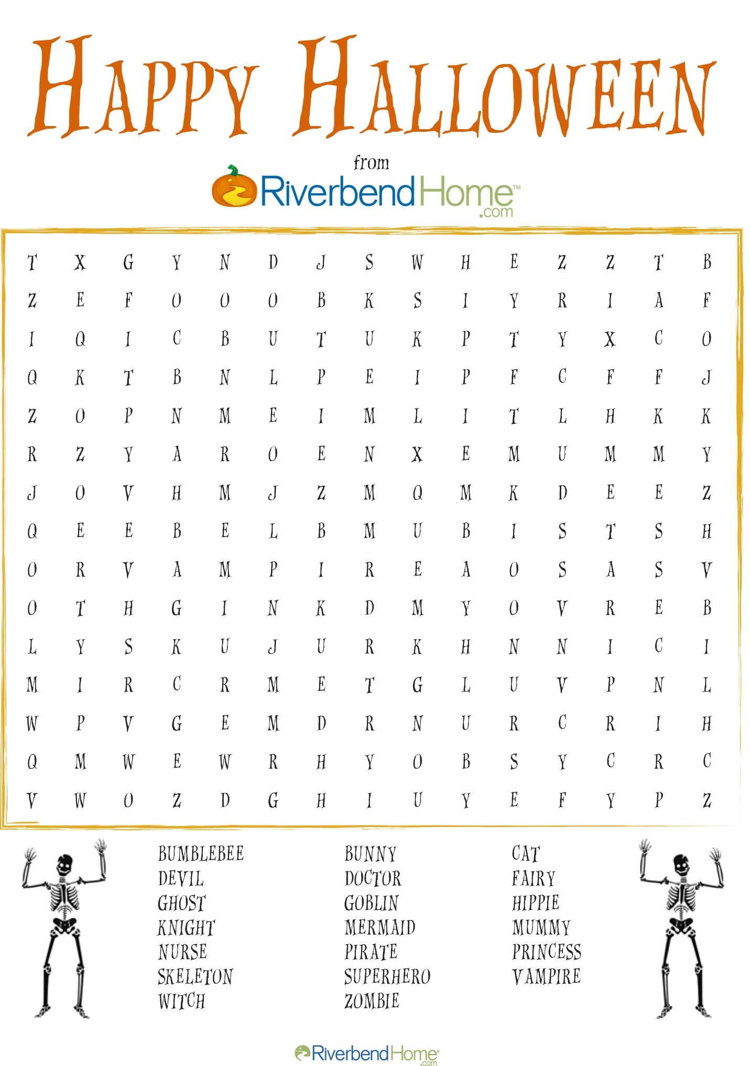

Halloween Resources
For your Listening Enjoyment: Halloween Music
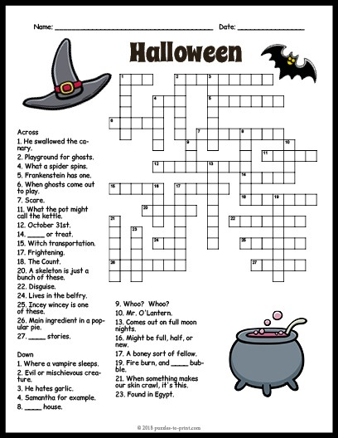

NEA Outreach Circle
OutreachCircle for the National Education Association. There are 5+ Actions available. Sign-in to join us and support our OutreachCircle.
Time to be an organizer! Help us expand the network of fellow members and public education supporting non-members using OutreachCircle by signing up at www.outreachcircle.com CODE:YXH825

It's Time to Renew NOW...

Thank you for your continued support!
﻿We would like to thank you for your past support of the NEA-NBCT Caucus! Your support allows the NEA-NBCT Caucus to continue working with NEA Leadership to create policies for our NEA members and students. We are proud to have you in our membership ranks!
﻿
Membership Year:
July 1, 2020 - June 30, 2021

Join/Renew Here

Don't let another year go by without your membership!
If you have already renewed, please forward to a friend!

